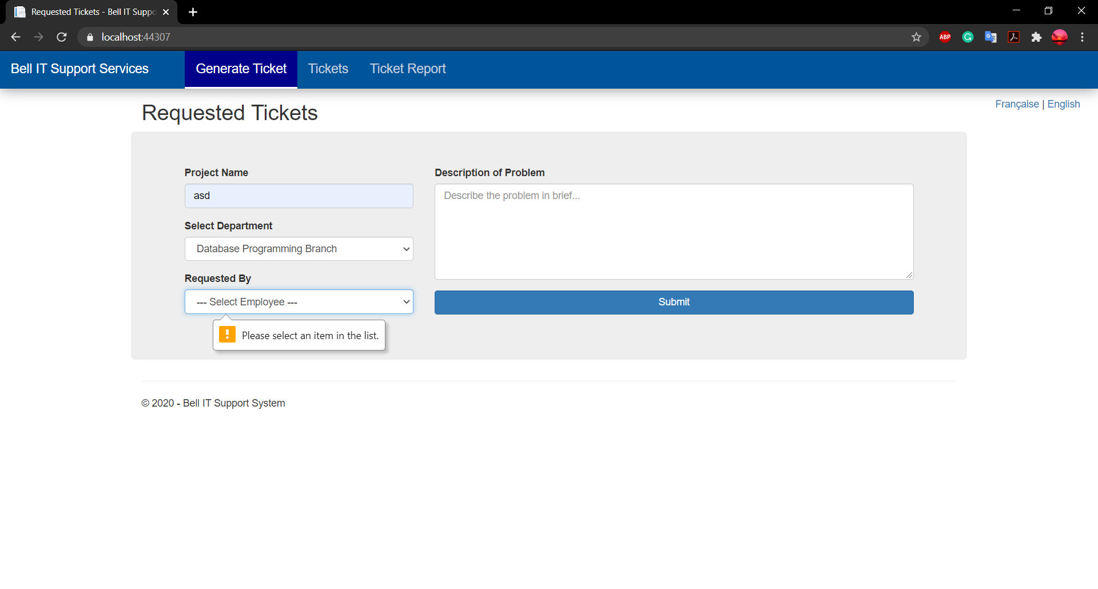

Note: Please Select Department to populate Employees Dropdown list

\*All Fields are mandatory

\*The Top Right corner will handle the language of this project

View All Tickets Page

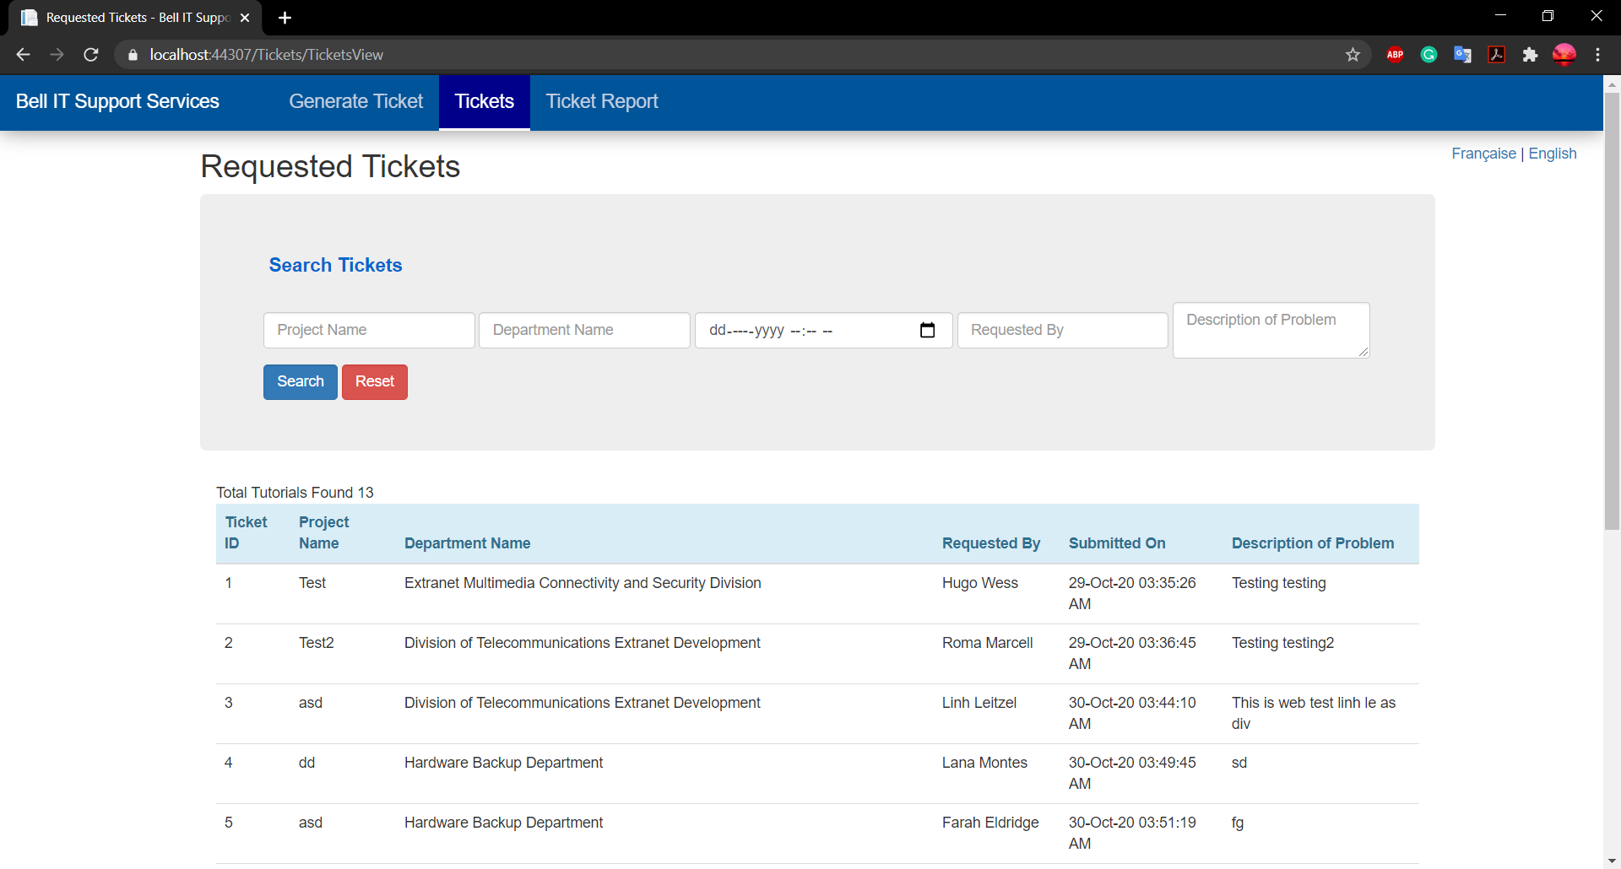

Note: Search will work on every row so wherever it finds match it will show the data independently according to search and will not group with other search criteria

Click on table header to sort the table accordingly

The Ticket Report/Chart page

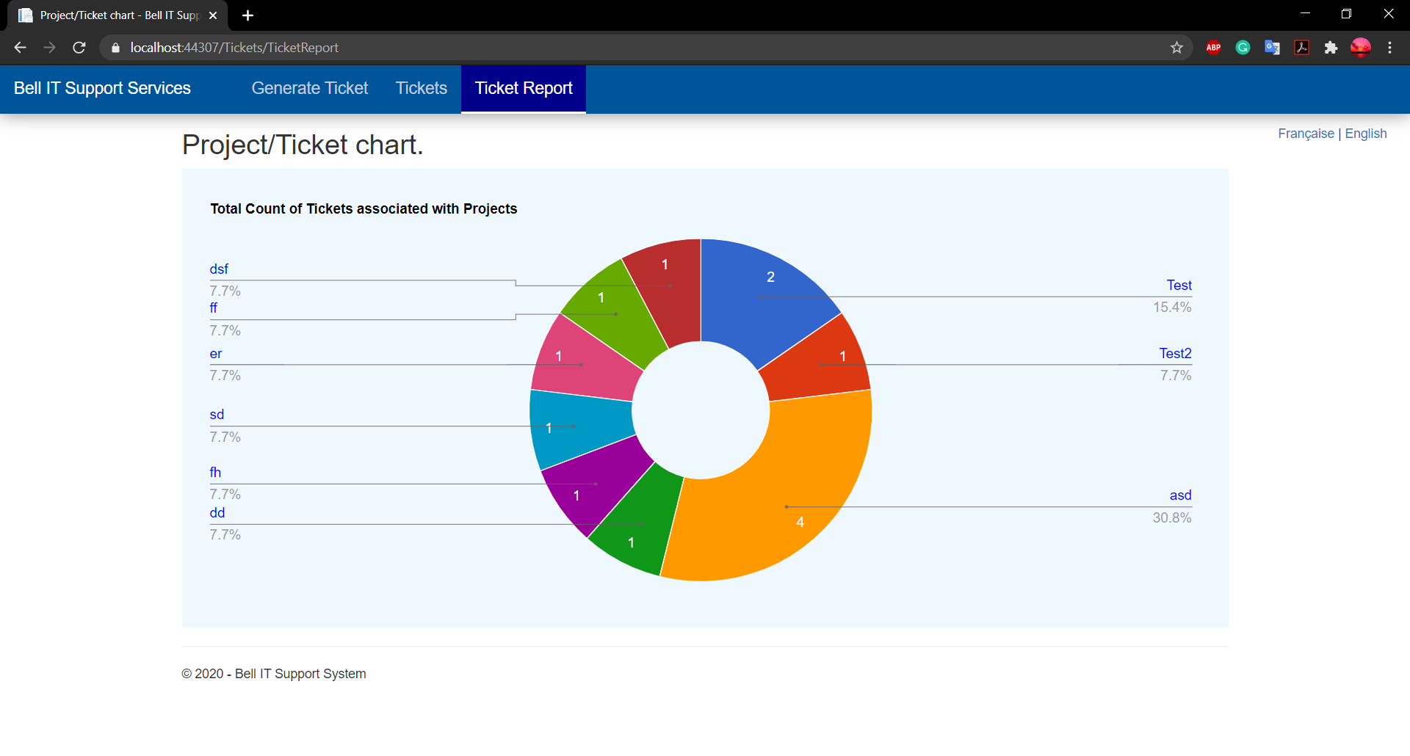

\*Chart is built using Google Chart API